Generated OWASP ZAP report and your detailed analysis:

Task A: Consolidate Vulnerability List & Analysis
The list of critical, high, medium, and low-severity vulnerabilities are:
- Vulnerability List:
  - Critical: 0
  - High: 1
    - User Controllable HTML Element Attribute (Potential XSS).
  - Medium: 0
  - Low: 4 (See ZAP Report, generally Informational alerts are treated as Low/Informational).
- Mitigation Plan for High-Severity Alert:
  - Vulnerability: User Controllable HTML Element Attribute.
  - Potential Impact: If left unaddressed, this could allow an attacker to inject client-side scripts (XSS). Impact includes session hijacking, redirecting users to malicious sites, or unauthorized data extraction from the user's browser.
  - Mitigation: The application must implement output encoding for all user-controlled data that is reflected back to the browser, specifically encoding values used in HTML element attributes. Alternatively, use a modern secure framework that handles output encoding by default.

Task B: Before-and-After Description
Since you likely cannot fix the code and re-run ZAP immediately, you need to provide a detailed description of the mitigation:
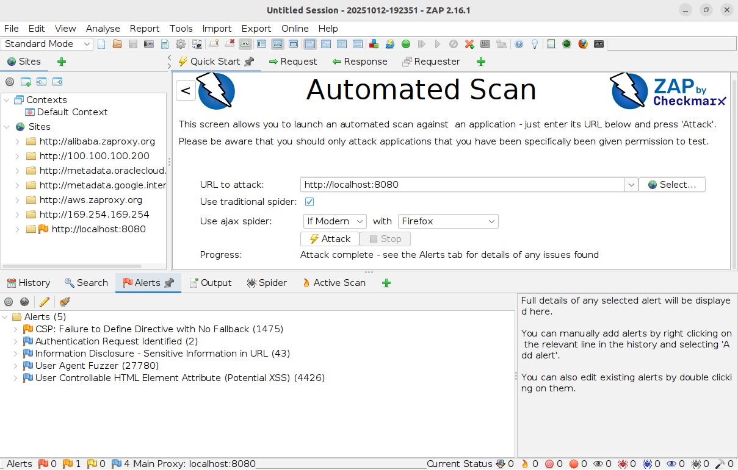
- Before Snapshot: ZAP report's finding of the High-severity XSS alert.

- After Description: The developer would modify the application code to implement robust input validation and output encoding to ensure user-supplied data cannot execute as code in the HTML element attribute. After the code fix, a re-scan would show the Alerts count drop to 0 High.

